International Cybersecurity and Digital Forensics Academy (ICDFA)
CIP-B101: Basic Computer Skills for Digital Forensics
LAB 2A PRACTICAL REPORT
Linux Command Line for Digital Forensics Basics
Student Name | Fuseini Imoru Kantuogaa
Course Code | CIP-B101
Course Title | Basic Computer Skills for Digital Forensics
Lab Code | Lab 2A
Lab Title | Linux Command Line for Digital Forensics Basics
Date | June 28, 2026
OS | Kali GNU/Linux Rolling (Version 2026.1) — hostname: kali
Kernel | Linux 6.18.12+kali-amd64 #1 SMP PREEMPT_DYNAMIC
Username | kali
Tools Used | bash, mkdir, ls, cat, echo, stat, df, find, tree, grep, ip, ping, ss, nmap, nano, chmod, zip, tar

1. Introduction
Linux is the dominant operating system in digital forensics because it is open-source, highly customizable, and provides low-level access to disk structures, file systems, processes and network interfaces. Forensic analysts use Linux command-line tools to acquire disk images without write-blocking software limitations, search for hidden or deleted files at the inode level, analyze logs, parse binary artifacts, automate evidence processing with shell scripts, and transfer evidence across networks. Understanding the Linux command line is therefore a prerequisite skill for any digital forensics professional.
This lab demonstrates eleven foundational skills: workspace organization, filesystem inspection, inode metadata analysis, path navigation, file management, log searching with grep, directory tree discovery with find and tree, safe local network verification, shell script creation, PATH manipulation, and evidence compression.

2. Lab Environment
Component | Details
Operating System | Kali GNU/Linux Rolling — VERSION="2026.1", VERSION_CODENAME=kali-rolling
Kernel | Linux kali 6.18.12+kali-amd64 #1 SMP PREEMPT_DYNAMIC (2026-02-25) x86_64
Username | kali (uid=1000, gid=1000)
Groups | kali, adm, dialout, cdrom, floppy, sudo, audio, dip, video, plugdev, users, netdev, scanner, bluetooth, lpadmin, wireshark, kaboxer
Disk | /dev/sda1 — 79G total, 62G used, 13G free (84% use)
Inodes | /dev/sda1 — 5,251,072 total, 490,200 used, 4,760,872 free (10%)
Evidence Workspace | ~/CIP-B101_Lab2A_Fuseini_Imoru/
Primary Tools | bash, mkdir, ls, cat, echo, stat, df, find, tree, grep, ip, ping, ss, nmap, nano, chmod, zip, tar

3. Tasks Performed

Task 1 — Prepare Evidence Workspace
The lab workspace was created using mkdir -p with sub-directories for notes, evidence, scripts, outputs, screenshots and archive. The pwd command confirmed the working directory and ls -la confirmed the folder was created. The student name "Fuseini_Imoru" was used in place of FIRSTNAME_LASTNAME throughout.
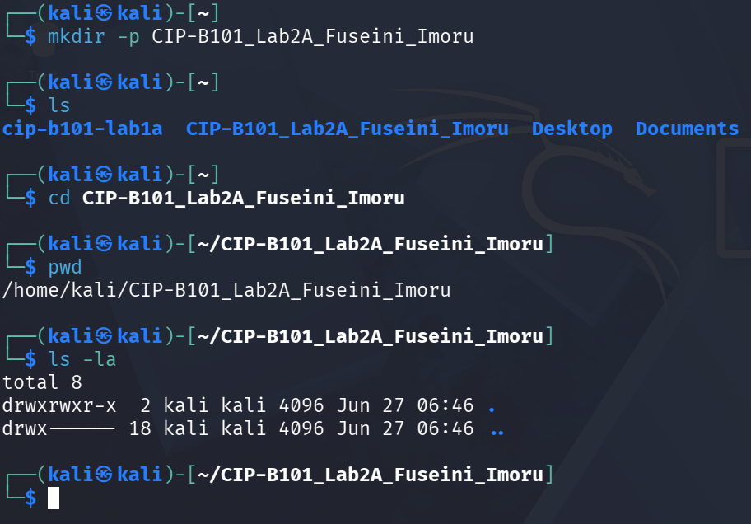
Screenshot 1a — mkdir -p creates CIP-B101_Lab2A_Fuseini_Imoru; pwd and ls -la confirm location at /home/kali/CIP-B101_Lab2A_Fuseini_Imoru.

Task 2 — Inspect Linux Filesystem and OS Information
The root filesystem was listed with ls / and ls -la / to show all top-level directories, their permissions and symbolic links. The OS was identified using cat /etc/os-release and uname -a, and the current user identity was confirmed with whoami and id.
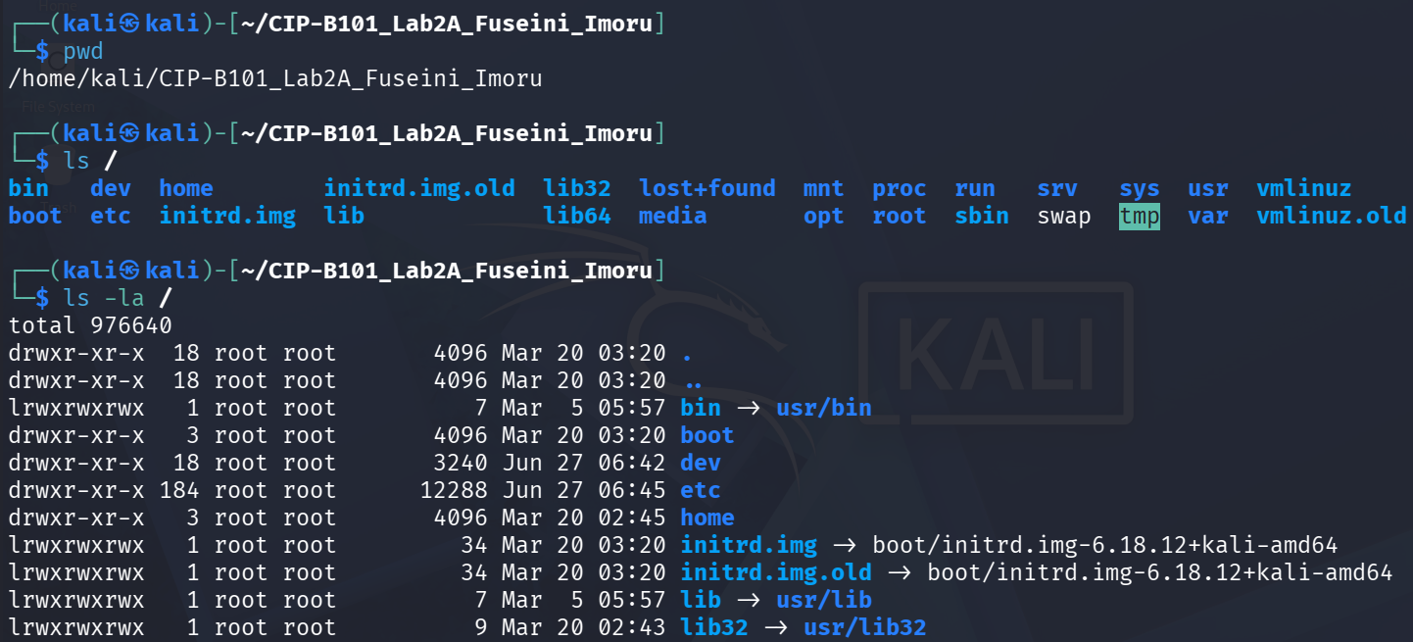
Screenshot 2a — ls / shows top-level directories; ls -la / reveals permissions and symlinks; cat /etc/os-release confirms Kali GNU/Linux Rolling 2026.1.
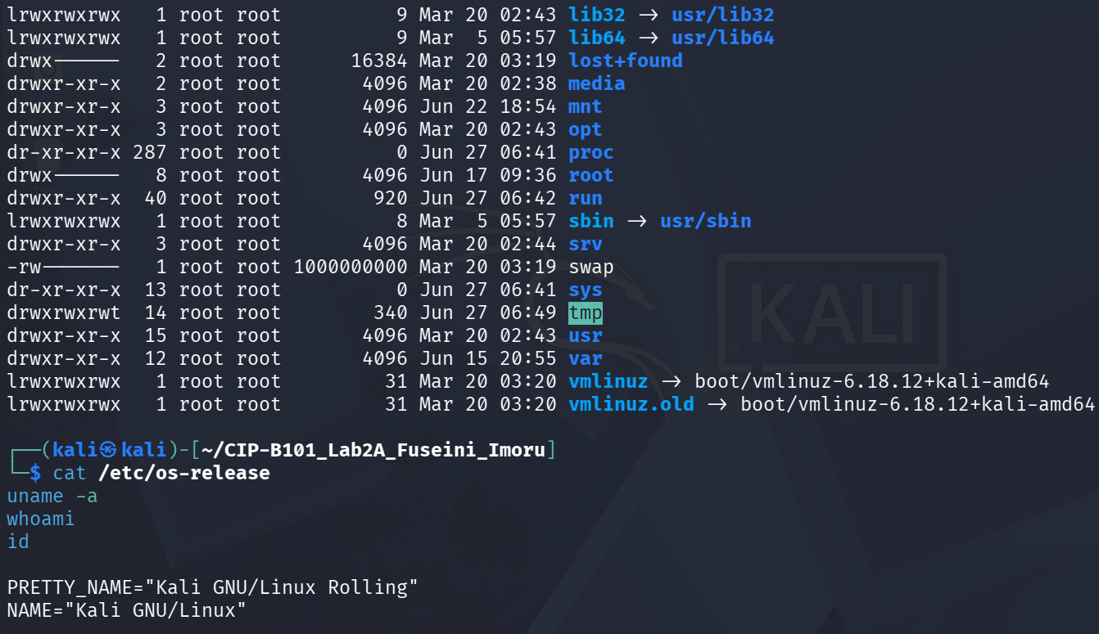
Screenshot 2b — Full ls -la / listing including /proc, /sys, /tmp; uname -a confirms kernel 6.18.12+kali-amd64; whoami=kali; id shows all group memberships.
Directory explanations:
/home — Contains home directories for all normal users. Forensic significance: user profiles, browser history, documents, and configuration files are found here.
/etc — System-wide configuration files (e.g. /etc/passwd, /etc/os-release). Forensic significance: user accounts, service configs, and authentication logs.
/proc — Virtual filesystem exposing live kernel and process information. Every running process has a numbered sub-directory. Not stored on disk; regenerated on each boot.
/sys — Virtual filesystem for hardware and kernel module information. Useful for identifying attached devices during acquisition.
/dev — Device files. Every hardware device (disk, USB, terminal) is represented as a file here. /dev/sda1 is the primary disk partition used throughout this lab.
/bin — Essential user binaries (now a symlink to /usr/bin in modern Kali). Contains basic commands like ls, cat, echo needed for early boot and recovery.
/tmp — Temporary files wiped on reboot. Forensic significance: malware and installers often write to /tmp; memory-mapped artifacts can appear here.

Task 3 — Inodes and Disk Information
An evidence file was created inside the evidence/ sub-directory. ls -li revealed its inode number (524452). stat provided the complete metadata block including size, block count, access/modify/change/birth timestamps, and permissions. df -h and df -i showed disk space and inode usage for all mounted filesystems.
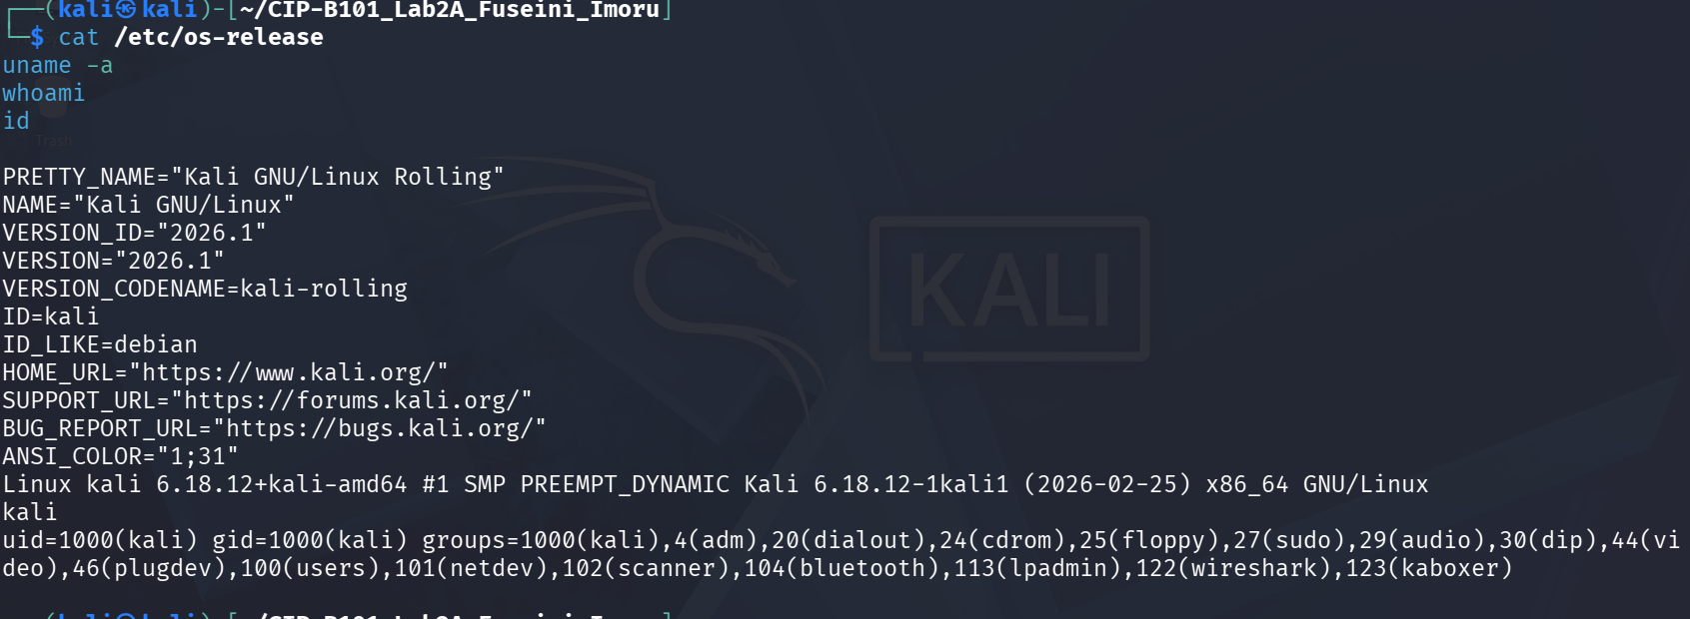
Screenshot 3a — evidence/lab2a_evidence.txt created; inode 524452 shown by ls -li; stat output shows all timestamps and 4096-byte IO block.
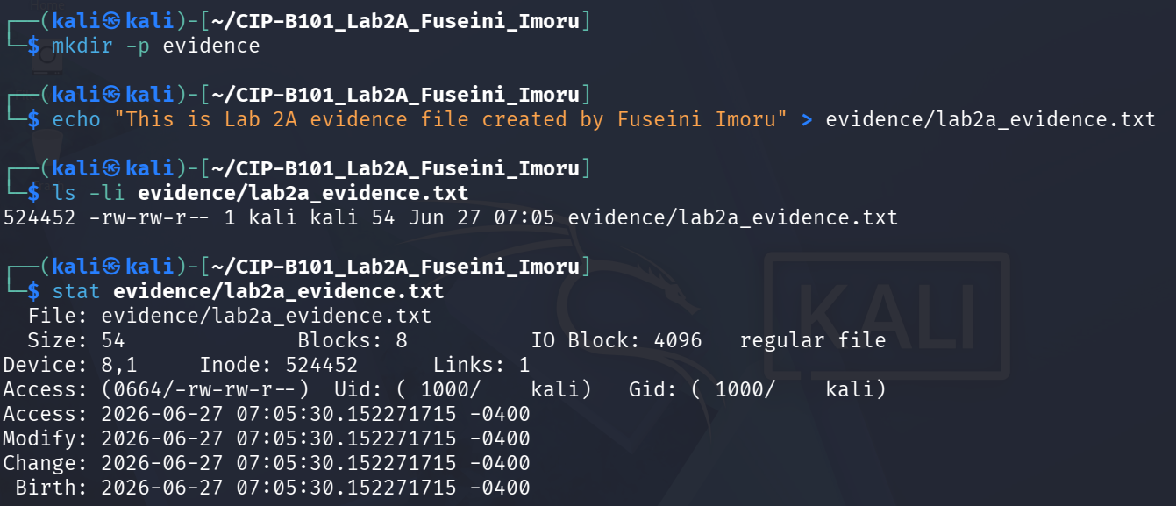
Screenshot 3b — df -h: /dev/sda1 79G, 62G used, 84%; df -i: 5,251,072 inodes, 490,200 used (10%) on main partition.
An inode is a data structure stored on the filesystem that contains all metadata about a file except its name. It stores: file size, owner UID and GID, permissions (mode), timestamps (access, modify, change, birth), block count, and pointers to the actual data blocks on disk. The file name is stored in a directory entry that points to the inode number. In digital forensics, inode data is critically important because: (1) the MAC times (Modify/Access/Change) recorded in the inode can establish a timeline of activity; (2) a deleted file’s inode may persist until overwritten, allowing recovery; (3) hard links to the same inode number reveal relationships between files; and (4) inode metadata survives renaming, which cannot be altered without changing the Change time.

Task 4 — Absolute and Relative Paths
Navigation was performed using both absolute paths (starting from /) and relative paths (using .. and . notation). The readlink -f command resolved the canonical absolute path of the evidence file.
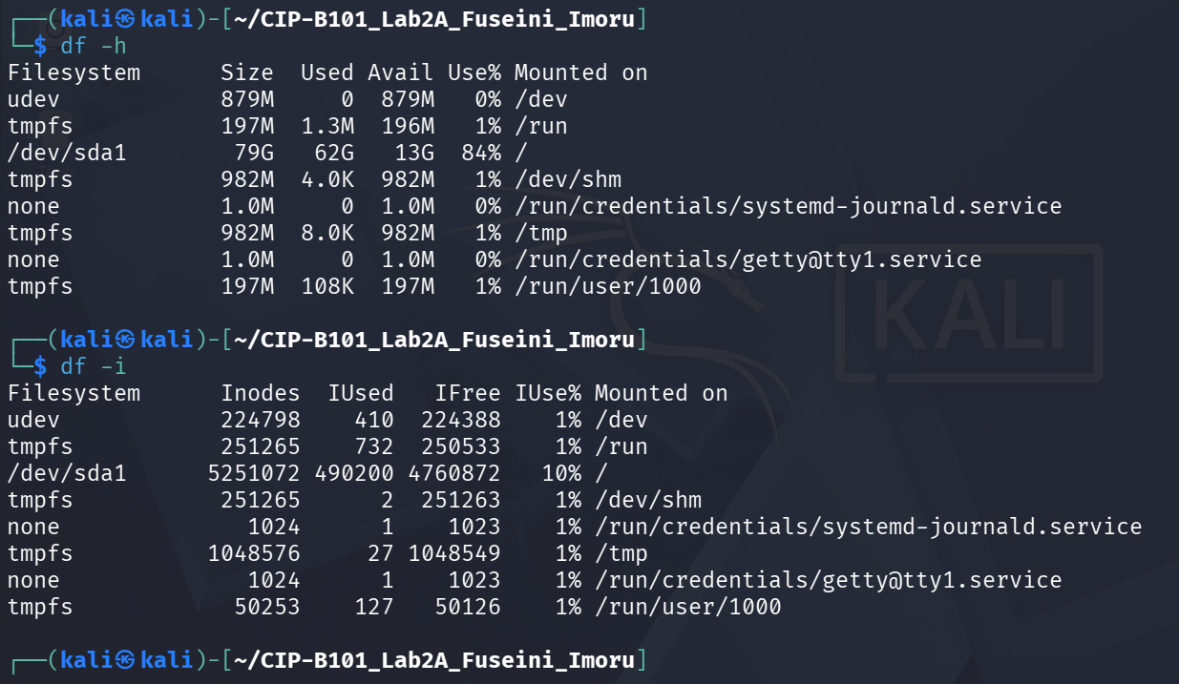
Screenshot 4a — cd to evidence (absolute); pwd confirms /home/kali/CIP-B101_Lab2A_Fuseini_Imoru/evidence; cd .. returns to parent; cd ./notes navigates to notes.
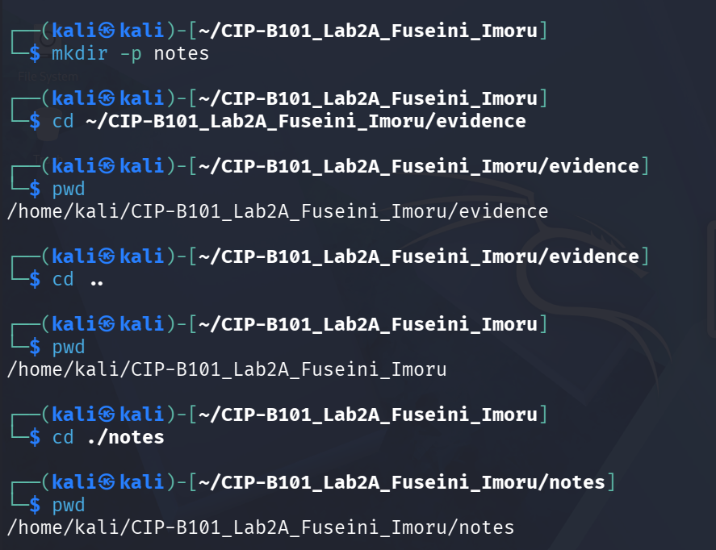
Screenshot 4b — cd ../evidence returns from notes; readlink -f confirms absolute path: /home/kali/CIP-B101_Lab2A_Fuseini_Imoru/evidence/lab2a_evidence.txt.
Absolute path: /home/kali/CIP-B101_Lab2A_Fuseini_Imoru/evidence/lab2a_evidence.txt
Relative path (from the lab root): ./evidence/lab2a_evidence.txt
Relative path (from the notes folder): ../evidence/lab2a_evidence.txt

Task 5 — Create, Copy, Rename and Remove Files
Two case notes were created in the notes/ folder, copied to evidence/, and one was renamed using mv. A temporary file was created and removed with rm. The ls -la evidence command confirmed the state of the directory before and after each operation.
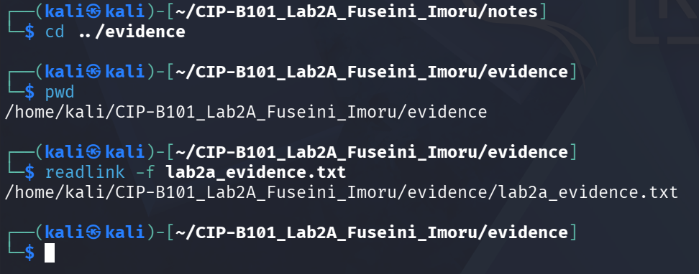
Screenshot 5a — case_note1.txt and case_note2.txt created; cat confirms content; cp and cp -r create copies; mv renames case_note1_copy.txt to case_note1_renamed.txt.
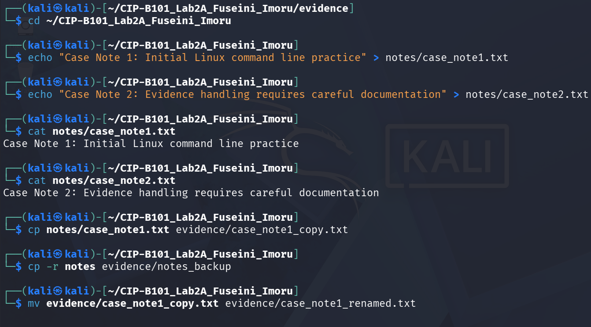
Screenshot 5b — ls -la evidence after rename shows case_note1_renamed.txt and notes_backup; temp_delete_me.txt created (15 bytes), then removed; final ls confirms deletion.

Task 6 — Search Evidence Content with grep
An activity log containing five simulated forensic events was created using a heredoc. Four grep commands were used to demonstrate different search modes: plain string search, line-number flagging, extended regex with alternation, and IP address pattern matching.
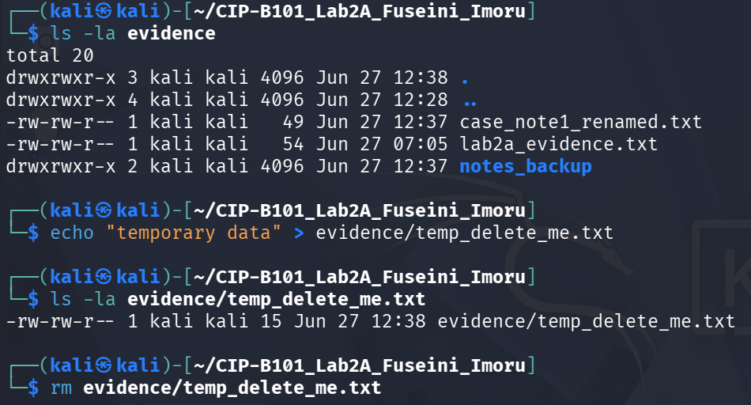
Screenshot 6a — Activity log created with cat heredoc; grep "login" returns both login events; grep -n "failed" returns line 3 with the failed admin login.
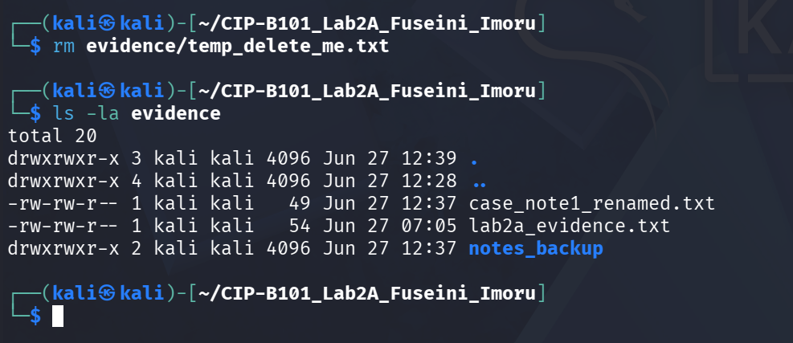
Screenshot 6b — grep -Ei "delete|password" returns the delete and password_change events; grep -Ei IP pattern returns both entries with 192.168.56.x addresses.
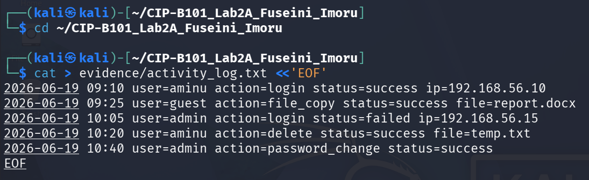
Screenshot 6c — grep -Ei "192\.168\.56\.[0-9]+" highlights IP addresses 192.168.56.10 and 192.168.56.15 in the log.
The command grep -n "failed" evidence/activity_log.txt shows failed login evidence — it reveals that admin attempted to log in from 192.168.56.15 at 10:05 and failed (line 3). The command grep -Ei "delete|password" evidence/activity_log.txt shows suspicious account activity — it surfaces the file deletion by user aminu and the password change by admin, both of which may warrant investigation in a real case.

Task 7 — Search File Names and Display Directory Tree
The tree command showed the entire evidence workspace in a visual hierarchy: 4 directories and 7 files. Three find commands located all .txt files, all files with "log" in the name, and the evidence directory itself.
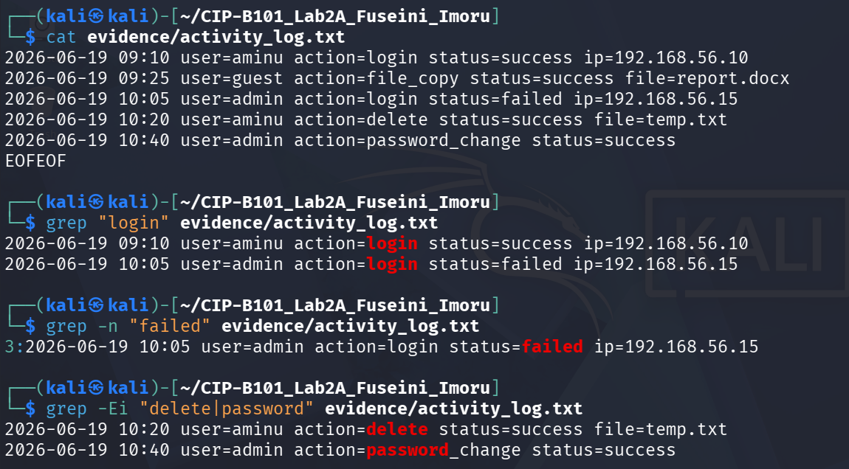
Screenshot 7a — tree shows full workspace: evidence/ contains activity_log.txt, case_note1_renamed.txt, lab2a_evidence.txt and notes_backup/; notes/ contains case_note1.txt and case_note2.txt.
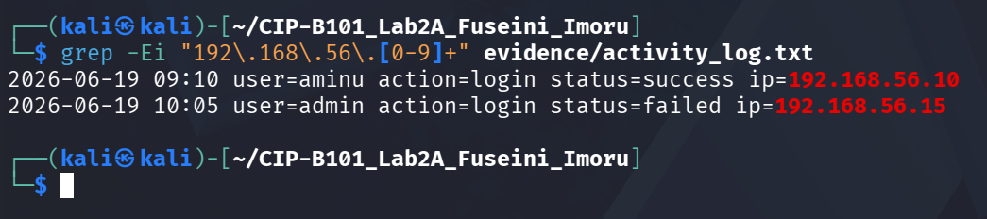
Screenshot 7b — find . -type f -name "*.txt" lists all 7 .txt files; find . -type f -iname "*log*" returns ./evidence/activity_log.txt; find . -type d -name "evidence" returns ./evidence.

Task 8 — Check Network Information Safely
Network interface details were obtained using ip addr (loopback 127.0.0.1/8 and eth0 192.168.44.128/24) and ip route (default gateway 192.168.44.2). Both loopback addresses were tested with ping -c 4; both returned 0% packet loss. The ss -lnt command showed no active listening TCP ports. Nmap was run against localhost on ports 22, 80 and 443; all were reported as closed.
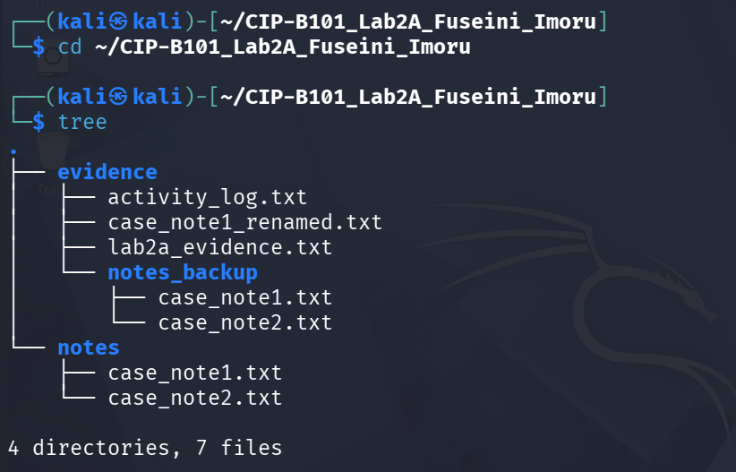
Screenshot 8a — ip addr confirms lo (127.0.0.1) and eth0 (192.168.44.128/24); ip route confirms default gateway 192.168.44.2.
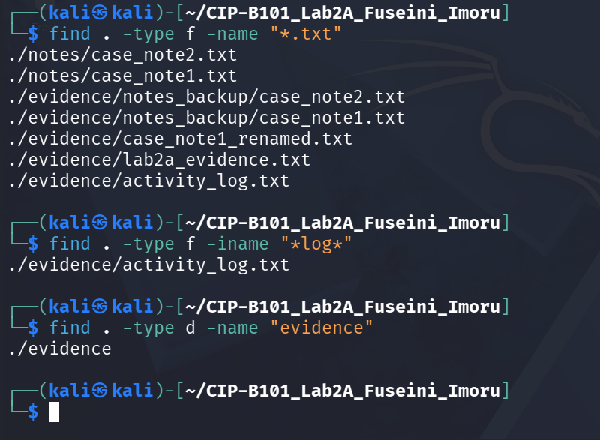
Screenshot 8b — ping -c 4 127.0.0.1: 0% loss, avg 0.064ms; ping -c 4 localhost (::1): 0% loss, avg 0.080ms.
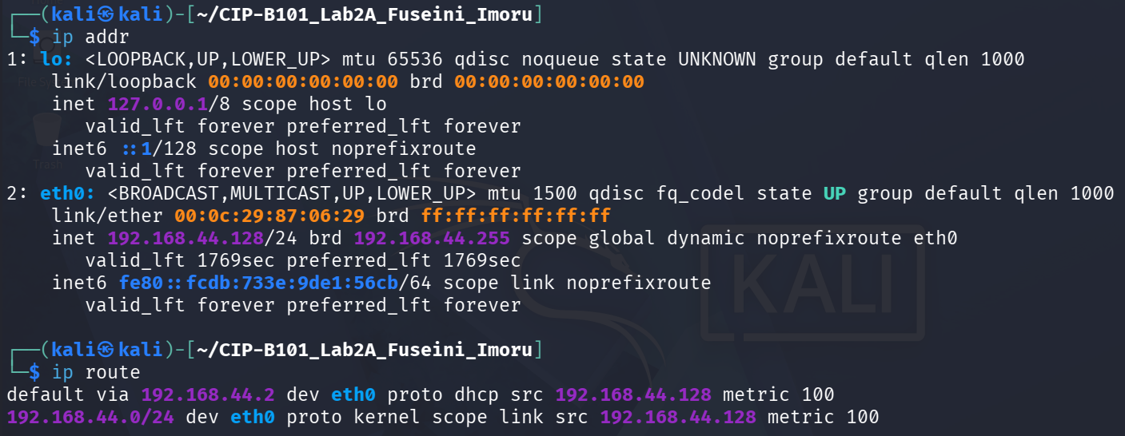
Screenshot 8c — ss -lnt shows no listening TCP sockets; nmap localhost confirms ports 22/80/443 all closed.
The loopback address 127.0.0.1 (IPv4) and ::1 (IPv6) refer to the machine itself. Testing against localhost is safe because packets never leave the network interface and cannot reach external systems. Scanning unknown external systems without authorization is illegal under computer misuse legislation and could constitute unauthorized access. In a forensic context, confirming that the acquisition machine has no unexpected listening services reduces the risk of data exfiltration during imaging.

Task 9 — Create and Execute a Simple Forensic Script
A shell script named lab2a_sys_summary.sh was created in the scripts/ folder using nano. The script collects date/time, username, hostname, kernel version, current folder, disk space, inode usage and the workspace tree, writing all output to outputs/system_summary.txt. The script was made executable with chmod +x and executed with ./lab2a_sys_summary.sh.
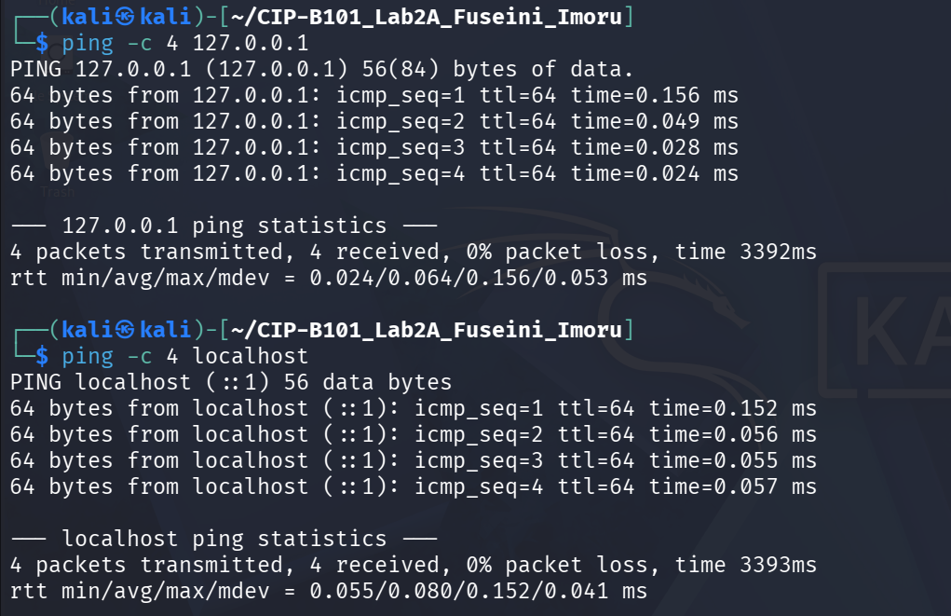
Screenshot 9a — scripts/ and outputs/ created; nano used to write the script; chmod +x applied; ls -l confirms -rwxrwxr-x permissions (558 bytes); ./lab2a_sys_summary.sh runs and reports "Summary saved".
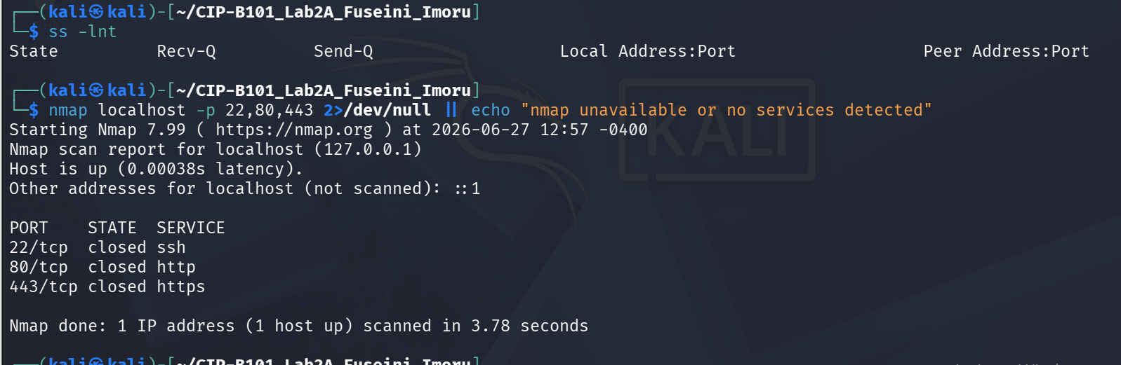
Screenshot 9b — cat system_summary.txt | head -n 30 shows the script output: date Sat Jun 27 01:05:21 PM EDT 2026, user kali, hostname kali, kernel, disk and inode tables.
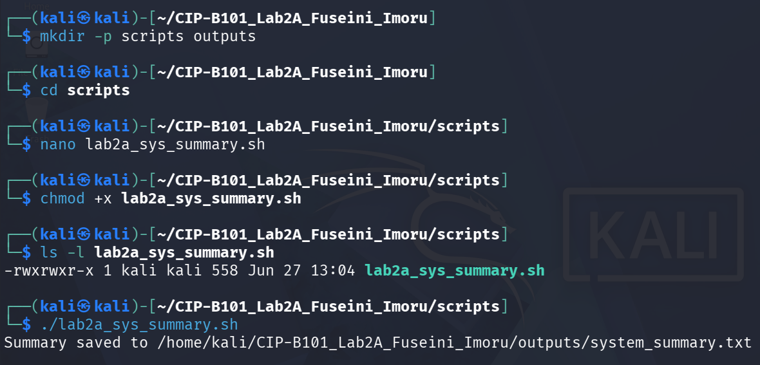
Screenshot 9c — Continued system_summary.txt output showing full inode table with /dev/sda1 at 10% inode usage and the beginning of the Evidence Workspace Tree section.

Task 10 — Make Script Callable Using PATH
The scripts/ directory was prepended to PATH using export PATH=$HOME/CIP-B101_Lab2A_Fuseini_Imoru/scripts:$PATH. The working directory was then changed to /tmp, and lab2a_sys_summary.sh was invoked by name without a path prefix. Linux found and executed the script because the shell searches all directories listed in PATH in order. The updated system_summary.txt was confirmed with head -n 15.
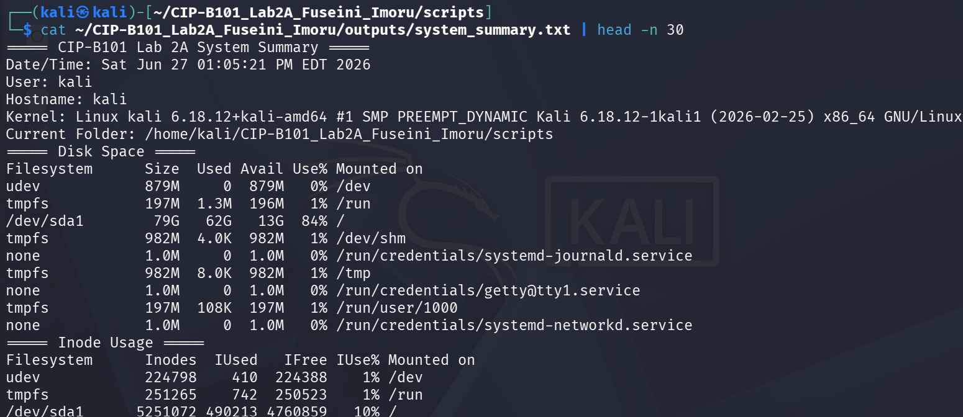
Screenshot 10a — PATH export; cd /tmp; lab2a_sys_summary.sh runs from /tmp and saves summary; ls scripts/ confirms lab2a_sys_summary.sh present; chmod +x reconfirmed.
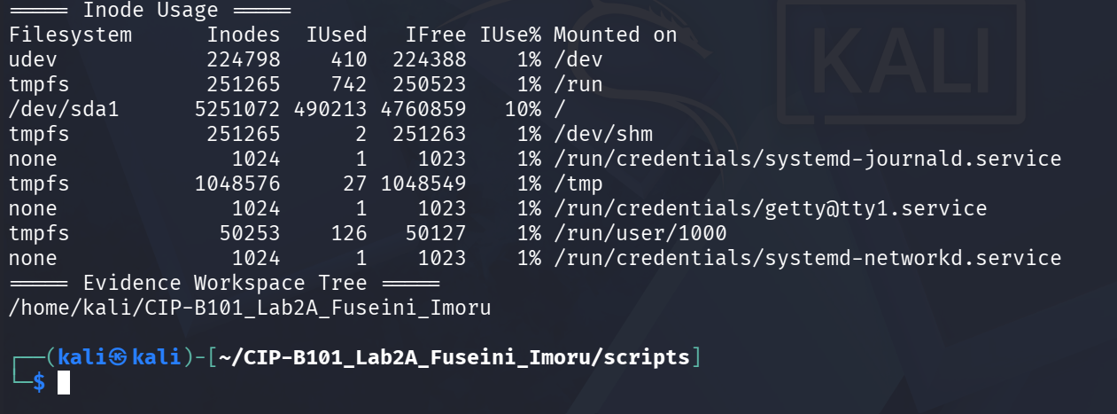
Screenshot 10b — cat system_summary.txt | head -n 15 from /tmp shows Date/Time Sat Jun 27 01:10:55 PM EDT 2026 and Current Folder: /tmp, proving the script ran from a different directory.
PATH is an environment variable that contains a colon-separated list of directories. When a command is typed without a full path, the shell searches each directory in PATH left to right until it finds a matching executable. Standard commands like ls exist in /usr/bin, which is always in PATH. By adding the scripts folder to PATH, the custom script became callable from any directory just like a built-in command. This is useful for forensic toolkits where scripts need to be accessible system-wide during an investigation.

Task 11 — Compress the Evidence Workspace
The complete workspace was compressed twice: once as a .zip file using zip -r, and once as a .tar.gz archive using tar -czvf. Both commands listed every file as it was added. The final ls -lh confirmed the .tar.gz (1.7K) and .zip (4.9K) archive sizes.
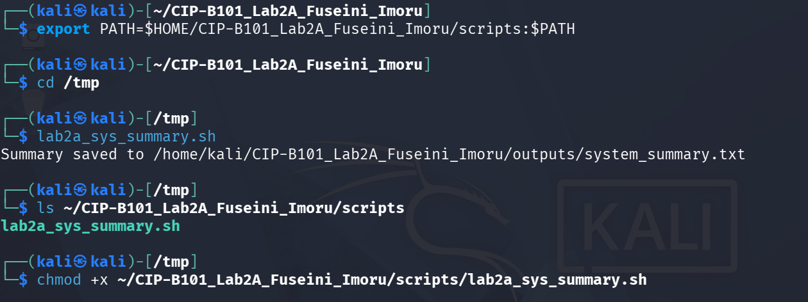
Screenshot 11a — zip -r creates CIP-B101_Lab2A_Fuseini_Imoru.zip; all files listed as added including scripts/lab2a_sys_summary.sh (deflated 48%).
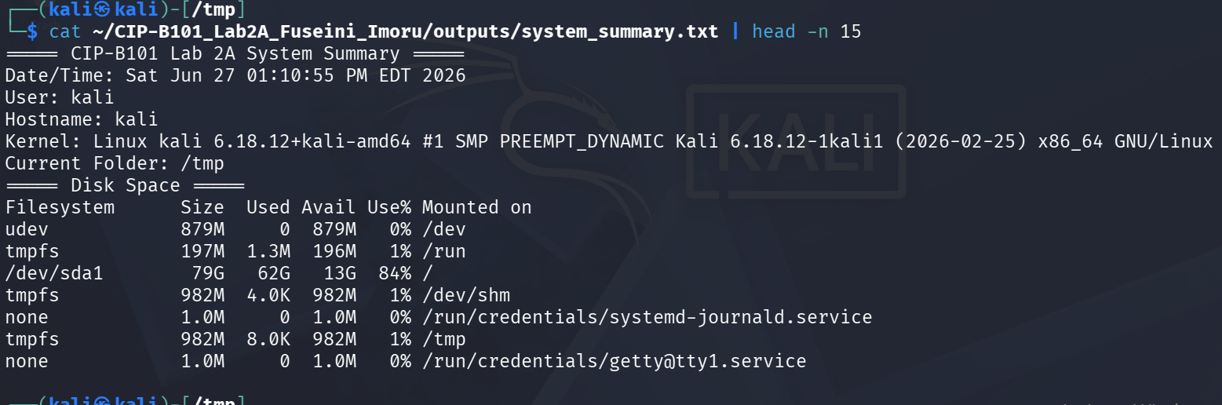
Screenshot 11b — tar -czvf creates CIP-B101_Lab2A_Fuseini_Imoru.tar.gz; all files and folders listed in the archive.
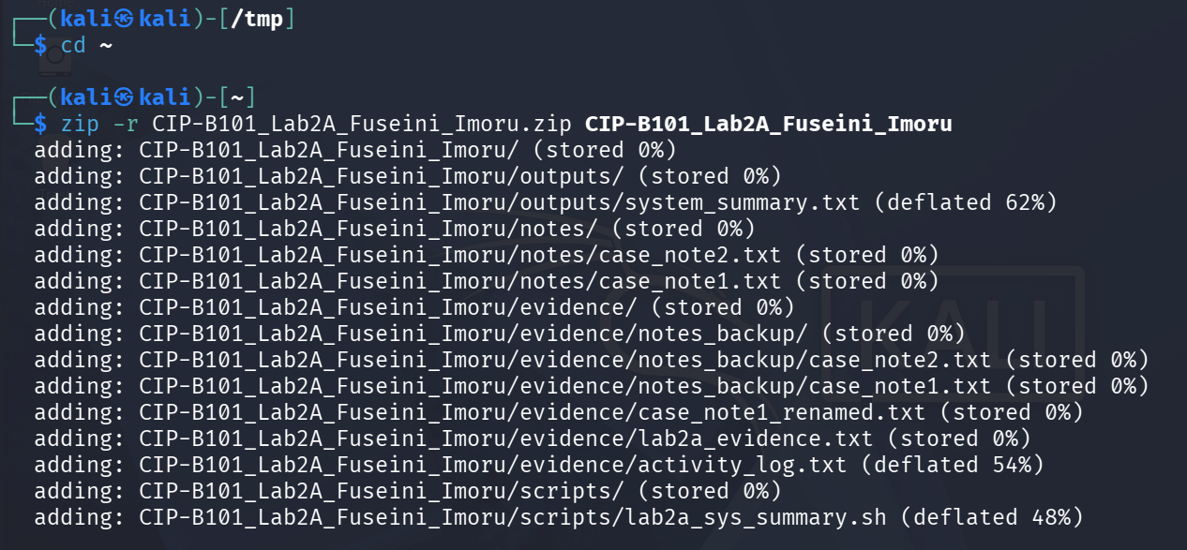
Screenshot 11c — ls -lh confirms both archives: CIP-B101_Lab2A_Fuseini_Imoru.tar.gz (1.7K, Jun 27 13:15) and CIP-B101_Lab2A_Fuseini_Imoru.zip (4.9K, Jun 27 13:14).

4. Findings
1. The Kali Linux VM (kernel 6.18.12+kali-amd64) provides all required forensic command-line tools without additional installation.
2. The inode number 524452 for lab2a_evidence.txt, with MAC timestamps of 2026-06-27 07:05:30, provides a verifiable metadata baseline that would support timeline analysis in a real investigation.
3. grep -n "failed" identified the only failed login in the activity log (line 3: admin from 192.168.56.15 at 10:05), and grep -Ei "delete|password" surfaced two additional high-interest events (file deletion and password change by admin).
4. The tree command confirmed 4 directories and 7 files in the workspace, and find successfully located files by extension, name pattern, and type without requiring a GUI.
5. All network tests used loopback addresses only (127.0.0.1 and ::1). Both ping tests returned 0% packet loss. No external hosts were scanned, satisfying the lab’s forensic safety requirement.
6. The forensic summary script ran successfully from /tmp after PATH modification, demonstrating that reusable automation tools can be made globally accessible without modifying system files.
7. Both compression formats (.zip at 4.9K and .tar.gz at 1.7K) packaged the entire workspace. The .tar.gz format achieved significantly better compression, which is expected for text-heavy content.

5. Reflection

Why is Linux preferred in digital forensics?
Linux provides direct, low-level access to disk devices, filesystems and processes through the /dev, /proc and /sys virtual filesystems. Its open-source nature allows forensic analysts to verify exactly what a tool does, reducing the risk of unexpected behavior during evidence acquisition. Linux also supports a wide range of forensic-specific tools (Autopsy, Sleuth Kit, Volatility, Wireshark) natively, and its scripting capabilities allow complex workflows to be automated and reproduced reliably. The "everything is a file" philosophy means network sockets, hardware devices and kernel interfaces can all be interacted with using the same read/write commands, simplifying tool development.

Why does inode metadata matter in forensics?
The inode stores MAC times the Modify time (when file content last changed), Access time (when the file was last read), and Change time (when inode metadata last changed). These three timestamps, combined with the Birth time on modern filesystems, allow an analyst to construct a precise timeline of file activity. Importantly, a file’s Change time updates even when only permissions or ownership are altered, and it cannot be manipulated by ordinary users in the same way as Modify time, making it a more reliable indicator of system events. Inode numbers also persist across renames, which means that tracking an inode allows an analyst to follow a file even if it was moved or renamed to conceal it.

What does the PATH variable do and why does it matter for forensics?
PATH tells the shell where to look for executable programs when a command is typed without a full path. By prepending a custom scripts directory to PATH, any script in that directory becomes callable from anywhere on the system. This matters in forensics because investigators often create small utilities (hash checkers, log parsers, acquisition scripts) that need to be accessible from any working directory without always typing absolute paths. It also matters for understanding attacker behaviour: malware frequently manipulates PATH to intercept calls to trusted binaries like ls or ps, substituting malicious versions a technique known as PATH hijacking.

6. Conclusion
This lab established eleven foundational Linux command-line skills that underpin all subsequent digital forensics work. Starting from workspace creation and filesystem exploration, through inode inspection, path navigation and file management, to evidence searching with grep, directory discovery with tree and find, safe network verification, shell scripting, PATH manipulation and evidence compression, every task produced documented, reproducible results.
The evidence file lab2a_evidence.txt was created with a known inode, its metadata was fully captured, and every grep command produced results that would be meaningful in a real investigation scenario. The forensic summary script demonstrated how repetitive data collection can be automated to reduce error and increase consistency. The final compressed archives are ready for submission alongside this report.
The skills practised here are directly applicable to disk imaging workflows (dd, identifying device files in /dev), log analysis (grep with regex), tool automation (shell scripting), and evidence packaging (tar/zip). They form the required foundation for the more advanced acquisition and stream-redirection techniques covered in Lab 2B.

Appendix — Additional Screenshots
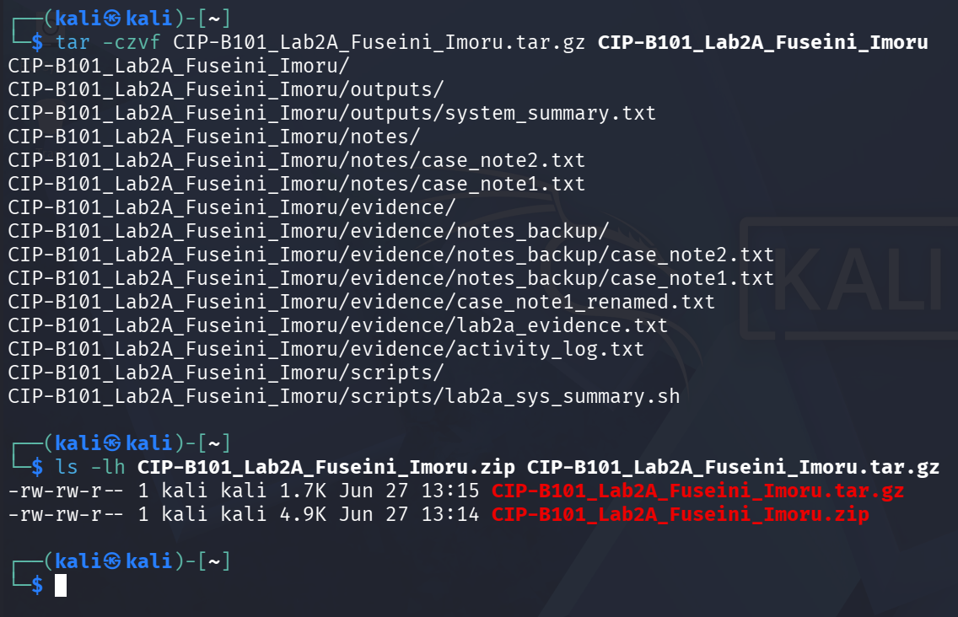
Appendix A — Full system_summary.txt output from PATH test in /tmp: shows date, user, hostname, kernel, current folder (/tmp), disk space, and inode tables.

